Chi-squared test
All chi-squared tests are concerned with counts of things (frequencies) that you can put into categories. For example, you might be investigating flower colour and have counted the numbers (frequencies) of red flowers and white flowers (categories). Or you might be investigating human health and have frequencies of smokers and non-smokers.
The test looks at the frequencies you obtained when you counted them and compares them with the frequencies you might expect to get in order to determine whether the difference is significant or not.

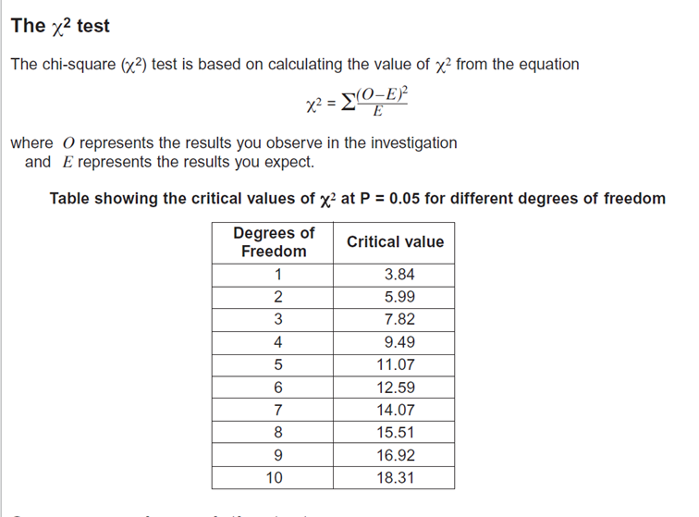
Chi-squared Worked Example 1. Snails on the Seashore
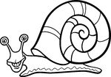
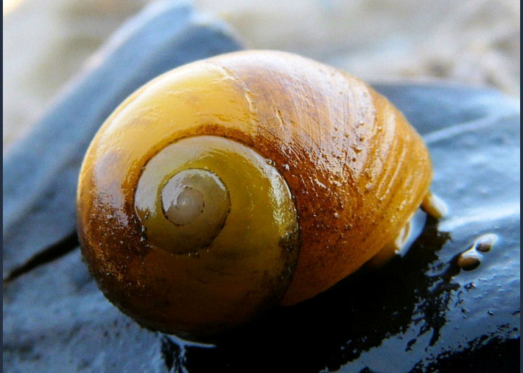

Why did the periwinkle blush?
Answer: because the sea weed!!

You have been wandering about on a seashore and you have noticed that a small snail (the flat periwinkle) seems to live only on certain types of seaweed. You decide to investigate whether the animals prefer to certain types of seaweed by counting numbers of animals on the different types of seaweed. You end up with the following data:
Type of Seaweed | Observed frequency  (the numbers of periwinkle)
serrated wrack | 45
bladder wrack | 38
egg wrack | 10
spiral wrack | 5
other seaweed | 2
TOTAL | 100

Null hypothesis
The null hypothesis when doing Chi-squared is
“there is no significant difference between the observed and expected frequencies.”
In other words, the periwinkle does not have a preference for which seaweed it lives on. This is now used to work out the ‘expected’ frequencies.

Expected Frequencies
Our null hypothesis is that there is no difference between the observed and expected frequencies. If this were exactly the case there would be no differences in the frequencies over all of our categories (i.e. the five types of seaweed). The best estimate we could make therefore would be to add up all our observed frequencies and divide by the number of categories. So our expected frequency for each category would be:
45 + 38 + 10 + 5 + 2 = 100
100 ÷ 5 = 20 = expected frequency
Type of Seaweed | Observed frequency | Expected frequency
serrated wrack | 45 | 20
bladder wrack | 38 | 20
egg wrack | 10 | 20
spiral wrack | 5 | 20
other seaweed | 2 | 20
TOTAL | 100 | 100

Calculating the Chi-squared value
Next we calculate the value of Chi-squared using the formula below.
O = Observed frequency
E = Expected frequency
The best way to show these calculations is in do this is in a table.
Type of Seaweed | Observed frequency | Expected frequency | O-E | (O-E)² | (O-E)² E
serrated wrack | 45 | 20 | 25 | 625 | 31
bladder wrack | 38 | 20 | 18 | 324 | 16
egg wrack | 10 | 20 | -10 | 100 | 5
spiral wrack | 5 | 20 | -15 | 225 | 11
other seaweed | 2 | 20 | -18 | 324 | 16
 |  |  |  |  | Total = 79
The total of our final column is the Chi-squared value. (= 79)
The ‘critical value’ & the ‘degrees of freedom’
Before we can interpret our results we need to work out the ‘critical value’. The critical value represents the borderline between accepting or rejecting our null hypothesis. We get the critical value from the data sheet, but this depends on the number of ‘degrees of freedom’.

Degrees of freedom = number of categories -1
'Degrees of freedom' is a term that can be bit confusing. A simple (though not completely accurate) way of thinking about degrees of freedom is to imagine you are picking people to play in a team. You have eleven positions to fill and eleven people to put into those positions. How many decisions do you have? In fact you have ten, because when you come to the eleventh person, there is only one person and one position, so you have no choice. You thus have ten 'degrees of freedom' as it is called. So 11 categories but only 10 ‘degrees of freedom’. Hence, degrees of freedom = number of categories -1
Likewise, the periwinkle snail was found on the serrated wrack, bladder wrack, egg wrack, spiral wrack, or other seaweed. There are five categories (five different types of seaweed), so only 4 degrees of freedom.
Interpreting the results
Chi-squared gives a number which indicates how big the difference is between the observed data and the expected data.
If the Chi-squared value is small, then there is a small difference between the observed and the expected data. This means the null hypothesis is accepted (likely to be correct). In other words, the snails don’t mind which seaweed they live on!
If the Chi-squared value is huge, then there is a huge difference between the observed and the expected data. This means the null hypothesis is rejected. In other words, the snails do indeed have a preference for living on a particular seaweed.
Looking at the table above we can see that the critical value of Chi-squared at 5% significance (p=0.05) and 4 degrees of freedom is 9.49.
Our calculated value is 79
The calculated value is bigger (much bigger!) than the critical value. In a chi-squared test this means we must reject the null hypothesis. In doing this we are saying that the snails are not scattered about the various sorts of seaweed randomly. Biologists would infer that this means they seem to prefer living on certain species.
Our calculated value of Chi-squared is much larger than the critical value of Chi-squared.
There is less than 5% probability that the differences (between the observed and expected data) are due to chance.
We reject our null hypothesis.

It is worth pointing out that statistics of this kind tell you nothing about the biology of the situation. All we are saying is that our observed frequencies are different to our expected ones. (For example, you could criticise our approach by pointing out that it might be that there are not equal amounts of each type of seaweed on the shore for the animals to live on.)

Chi-squared Worked Example 2. Birds on the Bird-Table
Q: When should you buy a bird?
A: When it’s going cheep!
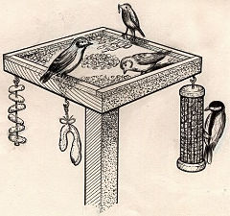
Three neighbours have very similar bird-tables in their gardens. Bill owns the middle garden and is a keen birdwatcher but he suspects that Kate, one of his neighbours, is actively encouraging birds away from Bill’s garden into her own somehow. Is Bill right?

Garden | Observed frequency  (the numbers of bird’s visiting the garden on one day in March)
Bill | 112
Kate | 145
Chris | 139
TOTAL | 396
Null hypothesis
The null hypothesis when doing Chi-squared is
“there is no significant difference between the observed and expected frequencies.”
Expected Frequencies and Calculating the Chi-squared value
We would expect the same numbers of birds to visit each garden if the null hypothesis is correct. A total of 396 birds were seen, so we would expect 132 in each garden (396 ÷ 3)
Garden | Observed frequency | Expected frequency | O-E | (O-E)² | (O-E)² E
Bill | 112 | 132 | -20 | 400 | 3.0
Kate | 145 | 132 | 13 | 169 | 1.3
Chris | 139 | 132 | 7 | 49 | 0.4
 |  |  |  |  | = 4.7

Degrees of Freedom
Degrees of freedom = number of categories -1

We have three categories (i.e. three gardens) so the degrees of freedom is 3-1 = 2
Interpreting the results
Looking at the table above we can see that the critical value of Chi-squared at 5% significance (p=0.05) and 2 degrees of freedom is 5.99.
Our calculated value is 4.7
The calculated value is smaller than the critical value. In a chi-squared test this means we must accept the null hypothesis. (In other words, Bill is not right! – Kate is not secretly putting out expensive bird-food to encourage the birds into her garden!)
Our calculated value of Chi-squared is smaller than the critical value of Chi-squared.
There is more than 5% probability that the differences (between the observed and expected data) are due to chance.
We accept our null hypothesis.

Chi-squared Question 1. Mendel and his Peas
Q: What do you call an angry pea?
A: Grump-pea.
Mendel planted some round peas which grew into plants that produced a total of 556 peas. 423 were round peas and 133 were wrinkled peas. Mendel postulated that round is dominant to wrinkled, and he work out the expected ratio for two heterozygous parent plants as 3:1. Do his experimental data support his 3:1 expected ratio? (Expected = 417:139)
Null hypothesis Write the null hypothesis here.
…………………………………………………………………………………………………
…………………………………………………………………………………………………
Calculating the Chi-squared value
Shape of pea | Observed frequency | Expected frequency | O-E | (O-E)² | (O-E)² E
 |  |  |  |  | =
Interpreting the results
How many degrees of freedom are there? ………………
What is the critical value (from the table)? …………………..
Our calculated value of Chi-squared is larger/smaller than the critical value of Chi-squared.
There is more/less than 5% probability that the differences (between the observed and expected data) are due to chance.
We accept/reject our null hypothesis.

Chi-squared Question 2. The West-Africian bee-eaters
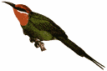
You have just returned from a 3 year stint in the jungles of western Africa, where you studied the habitat selected by the native bee-eaters (a family of birds that specialize in catching bees and wasps on the wing, taking them to a perch, bashing their stingers out, and devouring them. In a pinch, they will eat other flying or hopping insects, such as grasshoppers). Several habitats were available to the bee-eaters. Is there evidence to suggest that birds prefer a particular habitat?
 | Forest floor | Understory layer | Canopy layer | Emergent layer | Grassland | Field | River-bank
Number of birds | 3 | 15 | 17 | 20 | 3 | 11 | 4
Null hypothesis Write the null hypothesis here.
…………………………………………………………………………………………………
………………………………………………………………………………………………
Calculating the Chi-squared value
Interpreting the results
How many degrees of freedom are there? ………………
What is the critical value (from the table)? …………………..
Our calculated value of Chi-squared is larger/smaller than the critical value of Chi-squared.
There is more/less than 5% probability that the differences (between the observed and expected data) are due to chance.
We accept/reject our null hypothesis.

More Chi-squared problems.
- One section of a river was trawled and four species of fish counted and frequencies recorded. There were 15 Rudd, 15 Roach, 4 Dace and 6 Bream. Are the fish present in the river in equal proportions?

- An optician noticed the following information about colour-blindness in males and females. Is there a significant difference between the between the observed frequency of colour blindness in males and females?
Observed frequencies | Males | Females
Colour blind | 56 | 14
Not colour blind | 754 | 536
- The table below shows the number of patients requesting an urgent appointment to see a Doctor on particular days of the week. Are the differences significant?
 | Monday | Tuesday | Wednesday | Thursday | Friday
Numbers of patients | 125 | 88 | 87 | 94 | 108
- Cranes are large birds. Biologists have used DNA hybridisation to confirm the relationships between different species of crane. They made samples of hybrid DNA from the same and from different species. They measured the percentage of hybridisation of each sample. The results are shown in the table. Are there any differences which are statistically significant?
Species of crane | Mean percentage DNA hybridisation
Grus americana and Grus monachus | 97.4
Grus monachus and Grus rubicunda | 95.7
Grus americana and Grus rubicunda | 95.5
Grus rubicunda and Grus rubicunda | 99.9
Grus americana and Grus americana | 99.9
Grus monachus and Grus monachus | 99.8

- The table shows the number of cases of tuberculosis in the East Midlands between 2000 and 2005. Are the differences in number of cases of tuberculosis significant?
Number of cases of TB per 100,000 of the population | 2000 | 2001 | 2002 | 2003 | 2004
 | 10.6 | 11.1 | 11.9 | 7.9 | 9.9

