Q1.
This question is about structure and bonding.
(a) Figure 1 shows part of the structure of calcium oxide (CaO).
Figure 1
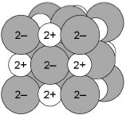
What type of bonding is present in calcium oxide?
Tick one box.

Covalent
Ionic
Macromolecular
Metallic
(1)
(b) Figure 2 shows a particle of methane (CH₄).
Figure 2
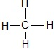
What type of particle is present in Figure 2?
Tick one box.

An ion
A lattice
A molecule
A polymer
(1)
(c) Figure 3 shows the structure of C₆₀
Figure 3
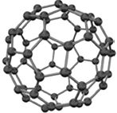
Complete the sentence.
Choose the answer from the box.

diatomic | giant ionic | a fullerene | giant metallic
The structure of C₆₀ is ________________________________________________ .
(1)
Figure 4 shows the structure of graphite.
Figure 4
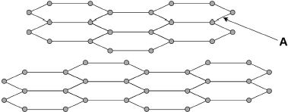
(d) What type of bond is labelled A in Figure 4?
Tick one box.

covalent
double
ionic
metallic
(1)
(e) In graphite, each carbon atom forms bonds with other carbon atoms as shown in Figure 4
How many electrons does one carbon atom use to form one bond?
Tick one box.

1 |  | 2 |  | 3 |  | 4
(1)
An electric current is passed through copper.
Figure 5 shows the apparatus used.
Figure 5
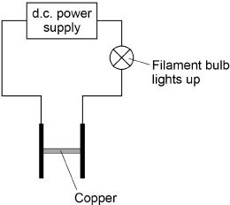
(f) Complete the sentence.
Choose the answer from the box.

gas | liquid | solid | solution
Figure 5 shows that copper conducts electricity as a ________________________ .
(1)
(g) Complete the sentence.
Choose the answer from the box.

atoms | electrons | ions | molecules
Copper conducts electricity because of the movement of delocalised ___________ .
(1)
(h) Figure 6 shows the apparatus used to investigate the effect of electricity on sodium chloride solution.
Figure 6
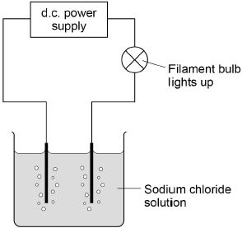
Complete the sentence.
Choose the answer from the box.

dissolved | gaseous | molten
Figure 6 shows that sodium chloride conducts electricity when ________________ .
(1)
(i) Sodium chloride is made up of ions.
Figure 7 shows the apparatus used to investigate the effect of electricity on solid sodium chloride and molten sodium chloride.
Figure 7
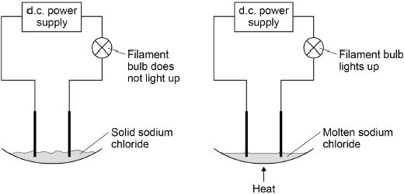
The table below shows the results.

 | Solid sodium chloride | Molten sodium chloride
Observation | The filament bulb does not light up | The filament bulb lights up
Deduction | Does not conduct electricity | Does conduct electricity
Draw one line from each statement to the correct reason.

Statement |  | Reason
 |  | The ions are fixed.
Solid sodium chloride does
not conduct electricity. |  | The ions are mobile.
Molten sodium chloride |  | The ions are neutral.
conducts electricity.
 |  | The ions are vibrating.
(2)
(Total 10 marks)
Q2.
This question is about the halogens.
(a) Which group in the periodic table is known as the halogens?
Tick one box.

Group 1
Group 2
Group 7
Group 0
(1)
(b) A fluorine atom has 7 electrons in the outer shell.
The diagram below shows part of a dot and cross diagram to represent a molecule of fluorine (F₂).
Complete the dot and cross diagram.
You should show only the electrons in the outer shells.
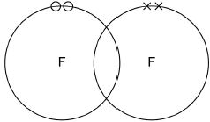
(2)
(c) Chlorine reacts with potassium bromide solution.
Complete the word equation.
potassium _________________
chlorine + bromide ⟶ _________________ +
_________________
(2)
(d) What type of reaction happens when chlorine reacts with potassium bromide solution?
Tick one box.

decomposition
displacement
neutralisation
precipitation
(1)
(e) Complete the sentence.
Choose the answer from the box.

an atom | an electron | a neutron | a proton
Chlorine is more reactive than bromine.
This is because chlorine gains ________________________________ more easily.
(1)
(f) How does the size of a chlorine atom compare with the size of a bromine atom?
Complete the sentence.
Choose the answer from the box.

bigger than | the same size as | smaller than
A chlorine atom is ______________________________________ a bromine atom.
(1)
(g) Give a reason for your answer to part (f)
Reason ____________________________________________________________
___________________________________________________________________
(1)
(h) Fluorine reacts with chlorine to produce ClF₃
Balance the chemical equation for the reaction.
Cl₂ + ________F₂ ⟶ 2 ClF₃
(1)
(i) Explain why fluorine is a gas at room temperature.
Use the following words in your answer:
energy forces molecules weak
___________________________________________________________________
___________________________________________________________________
___________________________________________________________________
___________________________________________________________________
___________________________________________________________________
___________________________________________________________________
___________________________________________________________________
___________________________________________________________________
___________________________________________________________________
___________________________________________________________________
___________________________________________________________________
___________________________________________________________________
___________________________________________________________________
(3)
(Total 13 marks)
Q3.
This question is about sodium and chlorine.
Figure 1 shows the positions of sodium and chlorine in the periodic table.
Figure 1
(a) State one difference and one similarity in the electronic structure of sodium and of chlorine.
Difference __________________________________________________________
___________________________________________________________________
Similarity ___________________________________________________________
___________________________________________________________________
(2)
(b) Sodium atoms react with chlorine atoms to produce sodium chloride (NaCl).
Describe what happens when a sodium atom reacts with a chlorine atom.
Write about electron transfer in your answer.
___________________________________________________________________
___________________________________________________________________
___________________________________________________________________
___________________________________________________________________
___________________________________________________________________
___________________________________________________________________
___________________________________________________________________
___________________________________________________________________
(4)
(c) The reaction between sodium and chlorine is an exothermic reaction.
Complete the reaction profile for the reaction between sodium and chlorine.
Figure 2
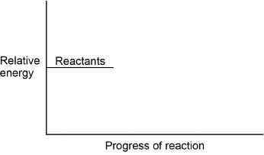
(2)
(Total 8 marks)
Q4.
This question is about structure and bonding.
(a) Figure 1 shows part of the structure and bonding in diamond.
Figure 1
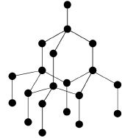
Explain why diamond has a high melting point.
___________________________________________________________________
___________________________________________________________________
___________________________________________________________________
___________________________________________________________________
___________________________________________________________________
___________________________________________________________________
___________________________________________________________________
___________________________________________________________________
___________________________________________________________________
___________________________________________________________________
(3)
(b) Figure 2 shows part of the structure and bonding in sodium chloride (NaCl).
Figure 2
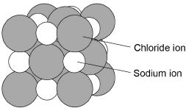
Explain the conditions needed for sodium chloride to conduct electricity.
___________________________________________________________________
___________________________________________________________________
___________________________________________________________________
___________________________________________________________________
___________________________________________________________________
___________________________________________________________________
___________________________________________________________________
___________________________________________________________________
___________________________________________________________________
___________________________________________________________________
___________________________________________________________________
(3)
(c) Figure 3 shows the structure of sodium.
Figure 3
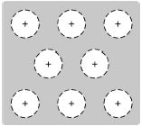
Describe how sodium conducts thermal energy.
___________________________________________________________________
___________________________________________________________________
___________________________________________________________________
___________________________________________________________________
___________________________________________________________________
___________________________________________________________________
___________________________________________________________________
___________________________________________________________________
___________________________________________________________________
___________________________________________________________________
___________________________________________________________________
___________________________________________________________________
___________________________________________________________________
___________________________________________________________________
(3)
(Total 9 marks)

