UTC South Durham Attendance Policy | 

Date of adoption | December 2025
Approved by | Governing Body
Signed: (Principal)   | Date:  12 December 2025
Signed: (Chair of Governors)   | Date:  12 December 2025

Date to be reviewed by | September 2028
Review History | Reviewed – Leanne Tippey Nov 19  Reviewed – Julie Bushby Dec 20  Reviewed – Tom Dower Dec 21  Reviewed – Catherine Purvis-Mawson April 22  Reviewed – Laura McAllister Sept 22  Reviewed – Laura McAllister July 24  Reviewed – Laura McAllister Oct 25
Responsibility | Principal

1. Introduction

Promoting positive behaviour and outstanding attendance is the responsibility of the whole UTC South Durham community, in preparing students for future employment.

The UTC will promote positive behaviour and outstanding attendance through its use of curriculum and learning materials. Outstanding attendance will be recognised appropriately. All students should be at the UTC, on time, every day the UTC is open, unless the reason for the absence is authorised. We understand, however, that travel to the UTC is complex for some students and is not always in their control.

Any problems that arise with attendance are best resolved between the UTC, the parents/carers and the student. Permitting absence from the UTC without a good reason is an offence by the parent.

The UTC has a duty in law to refer any absence of three days or more where we have been unable to make contact with the parent/child or have general concerns about the absence to other agencies.

We are also required by law to take an attendance register twice a day, and this shows whether the student is present, engaged in an approved educational activity off-site, or absent. Only the UTC can authorise an absence, not parents. This is why information about the reason of each absence is always required on a daily basis.

2. Guiding principles

The purpose of this policy is to:

- Ensure that students attend the UTC (including employer partners when on placement) unless prevented by illness or another authorised reason
- Reduce the impact on teaching and learning and therefore student progression due to absence from lessons
- Ensure that staff, parents and students are aware of their legal responsibilities with regard to attendance

This attendance policy is based upon the following principles:

- Students attend the UTC every day, except when there is authorised illness or other abnormal circumstances
- Being late is unacceptable except in genuine, unavoidable circumstances
- Staff and parents encourage and support students to achieve and maintain outstanding attendance at UTC South Durham

The electronic registration system follows the Education (Pupil Registration/England) Regulations 2006 – amended 2010, 2011 and 2013

3. Roles and responsibilities

  - Governing Body

The Governors of the UTC will:

- Ensure the UTC has a robust attendance policy
- Ensure that the policy is available to parents
- Ensure that policies and procedures are reviewed regularly

3.2 Principal

The Principal will:

- Ensure the policy adopted by the Governors of the UTC is fully implemented and followed by the whole UTC community
- Ensure effective implementation of policy
- Organise appropriate staff training and awareness as required
- Monitor, review and evaluate the effectiveness of the policy according to the timescale for the review
- Report to Trustees (Governors) on request

3.3 Director of Student Wellbeing

The Director of Student Wellbeing will:

- Coordinate the procedures for dealing with attendance issues
- Oversee the SSOs in dealing with attendance issues
- Ensure all new staff are inducted in the implementation of the attendance policy
- Ensure that all students are fully aware of the contents of the attendance policy

3.4 Attendance Officer

The Attendance Officer will:

- Liaise with teachers/ mentors/Crew Leaders regarding student absence both from the UTC and from individual lessons and report weekly data to Crew leaders.
- Oversee the administration of lesson monitoring
- Liaise with parents when no explanation for absence has been received
- Inform the mentor/Crew Leader about students reported as missing from lessons
- Liaise with the mentor/Crew Leader over attendance patterns and follow up where necessary.
- Run regular attendance checks as requested by the Senior Leadership Team
- Report weekly to the Deputy Principal regarding attendance / punctuality
- Provide attendance data for the Principal and Trustees on a half-termly basis
- Provide attendance data to inform Crew league tables.
- Identify students who need support in line with the UTC staged approach to attendance (appendix *)
- Identify students for ½ termly, termly and yearly rewards for 100%/97%/maintaining/improving attendance.

3.5 SLT Attendance Champion

The SLT Attendance Champion will:

- Ensure attendance remains central to the schools’ vision.
- Monitor and analyse weekly attendance patterns to ensure early intervention.
- Conduct thorough analysis of half-termly, termly and full year data.
- Monitor the impact of improvement work.

3.6 Reception staff

The administrative staff based at the main reception will:

- Report and inform late arrivals to Attendance Officer and summon the member of staff on-call to escort late students to lessons.
- Confirm medical appointments and forward evidence to Attendance Officer
- Advise of students leaving due to illness/medical

3.7 All Teachers / mentors/ Crew Leaders

Teachers / mentors/Crew Leaders at the UTC will:

- Ensure they are fully conversant with the attendance policy and appendices
- Ensure that all registers are completed as required by the appendix relating to procedures
- Ensure that all concerns relating to attendance are brought to the attention of the Attendance Officer
- Conduct weekly attendance conversations with Crew groups.
- Regularly praise individuals for good and improving attendance, implementing the attendance rewards system.
- Regularly challenge absences with students and report any concerns to the Attendance Officer or via CPOMS where there is a safeguarding concern.
- Foster positive relationships with parents/carers to support removing barriers to poor attendance.
- Attend meetings with parents, along with the Attendance Officer and other relevant members of staff to address poor attendance.

3.8 Parents/Carers

Parents/Carers of students at the UTC:

  - Have a legal duty to ensure that their child attends and stays at the UTC, and that they arrive on time
- Provide medical evidence in advance to support an absence i.e. appointment card, hospital letter
- Should inform the UTC on the first day of absence, by telephone, stating the reason for absence. If the absence continues the UTC must be notified every day

4. Absences

Only absences authorised by the UTC can be accepted. These are occasions when:

  - The student is ill and absence is supported by medical evidence
  - The student is absent with leave of absence granted by the Principal
  - The student belongs to a religious body which sets aside days for religious observance;
  - The student has been excluded for a fixed period;
  - The student has been permanently excluded, but an appeal is in progress

The UTC will not accept a note from parents if the explanation given is not a valid reason for absence. The decision to authorise an absence rests with the Principal.

5. Leave of Absence

Leave of absence can only be authorised as such by the UTC and not the parent. Leave will not be granted except in genuine, unavoidable circumstances. It may be granted for the following:

  - Family bereavement
  - To attend an interview for employment or for a place at an institute of further / higher education
  - Authorised holidays

6. Unauthorised Absence

Any absence which has not been authorised by the UTC is recorded as unauthorised. Unauthorised absence will be viewed seriously, and steps will be taken, via a staged approach (appendix *), to discover the reasons. These will include:

  - Home contact including telephone calls, emails and letters
  - Attendance clinics with students
  - Attendance Officer home visits
  - Parental meetings

Should these steps fail to secure a student’s full attendance, the Local Authority may issue a Fixed Penalty Notice (FPN) or the Local Authority may start the non-attendance legal process, which could result in legal action in the Magistrates Court.

There is no automatic entitlement to leave for family holidays and we actively discourage parents from taking holidays during term time and as such it will be treated as unauthorised absence. Parents should be aware that students who miss external examinations through unauthorised family holiday will be charged the examination entry fees.

Students and parents must also consider the importance that future employers or educational organisations eg universities, place on students having first-class attendance and punctuality when offering positions / places. They will always ask a student’s departing school / UTC for their attendance and punctuality record. As such, good attendance is a vital part of students becoming Career and Life Ready.

6.1 Fixed Penalty Notices (FPN)

Fixed penalty notices are fines of £80 / £160 imposed on parents. They are an alternative to the prosecution of parents for failing to ensure that their child of compulsory school age regularly attends the school where they are registered or at a place where alternative provision is provided.

Fixed penalty notices are issued by the local authority. Penalty notices can be issued to each parent liable for the attendance offence or offences. Information for parents from the Local Authority in relation to FPN’s can be found in Appendix 7.

7. Punctuality

Punctuality is a requirement of attendance at the UTC and is an expectation of all future employers. Lateness will not be tolerated and will be monitored by the SLT, teachers and mentors. Lateness will be dealt with through the UTC Behaviour Management System:

  - The registers are taken by 8.45am
  - If a student arrives after 8.45am but before 9:45am it is recorded as an “L” – Late
  - If a student arrives after 9.45am the session is recorded as a “U” – late after registration has closed
  - If a student arrives late to any subsequent lessons by 5 minutes or more they will be recorded as L – late

We recognise that some students will be late because of transport arrangements and we will endeavour to support them in ensuring that they are on time when possible. If a student expects they will be late travelling on public transport they will be asked to call the UTC Student Support Team.

Students will be required to ‘pay-back’ time they have missed due to avoidable punctuality issues during breaks, lunchtimes and after school.

8. Truancy

Truancy is absence from the UTC or individual lessons without permission from the UTC.
Parents / carers will be informed about any instance of truancy.

Students who truant will be dealt with through the UTC Behaviour Management System. Students will be expected to catch-up missed work and time-owed through payback at break and lunchtimes.

Any truancy will be recorded on the UTC attendance system.

9. Procedures

The procedures for monitoring attendance and punctuality are detailed in the following appendices:

- Appendix 1 Guidance for staff on monitoring attendance at the UTC
- Appendix 2 Attendance Protocol KS4 and KS5
- Appendix 3 UTC South Durham staged approach to attendance.
- Appendix 4 Rewarding Good attendance
- Appendix 5 Supporting persistent and severely absent students
- Appendix 6 Guidance for Parents
- Appendix 7 Durham County Council FPN Information for Parents
- Appendix 8 Key Contacts

Appendix 1

Guidance for Staff: Procedures for Managing Attendance

Registration

Registers must be taken using the MIS Lesson Monitor program within the first 10 minutes of every lesson. If MIS is not available for any reason, staff should send a reliable student to Student Support Office to collect a class list. The register should be completed on the list and returned to the Attendance Officer. Students should not be marked present unless they have been present in the lesson. Registers are legal documents and it is essential that staff use the headcount facility to check numbers for legal and health and safety reasons. Concerns regarding student attendance should be raised with the Attendance Officer as soon as possible.

Lateness

Lateness is unacceptable without a genuine reason. Students who arrive after morning Mentoring/Crew session has finished, should report to Reception where they will be signed in. The UTC receptionist will then inform the Attendance Officer of lates, who will the update the MIS system accordingly. The member of staff ‘On-Call’ will be called to escort students who arrive late to school to their lesson. Persistent lateness will be dealt with via our behaviour system. A member of the Senior Team will also make a note of minutes late on arrival which is also uploaded to Classcharts to monitor the amount of time late.

Monitoring/Crew

Mentors/Crew Leaders should ensure that they monitor the attendance and punctuality of their cohort of students through MIS at least once every week. The Attendance Officer will run a weekly attendance report and present it to the Senior Leadership Team and Mentors/Crew Leaders. Crew Leaders should use this report to conduct weekly conversations with the students in their Crew, praising good, maintained and improving attendance and challenging absences.

Appendix 2

Attendance Protocol KS4
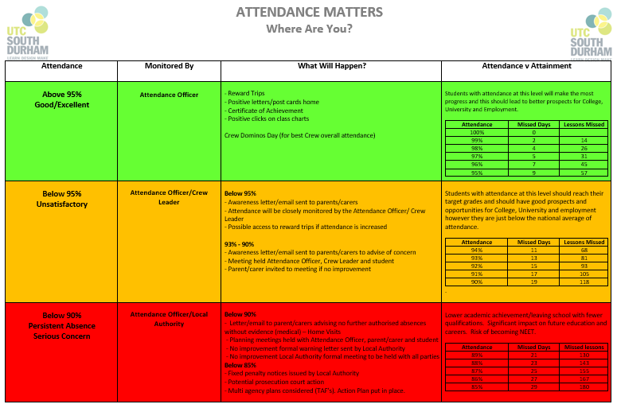

Any unauthorised absence will receive a call by the Attendance Officer.

*KS5 (Years 12 /13) these procedures should be applied with appropriate discretion and students / parents must realise that poor attendance could result in a student KS5 place at the UTC being withdrawn.

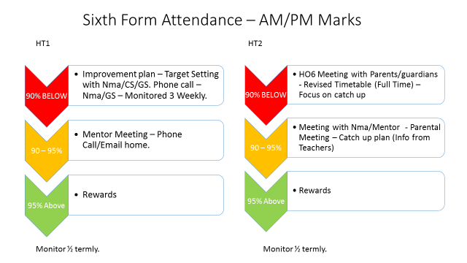

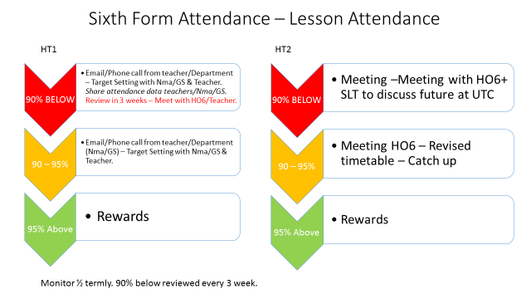

Appendix 3

UTC South Durham Staged approach to attendance
Stage | Intervention | Involved | Attendance level | Actions
0 | Weekly attendance conversation in Crew. Attendance informing inter-Crew League tables | All students and Crew Leaders, supported by JuB (finding data etc.) | Above 97% and those improving attendance. | - Crew Leaders praise students who are at 100% attendance  - Crew Leaders praise students who are meeting expectations 97%  - Crew Leaders praise students who are maintaining good attendance  - Crew Leaders praise students whose attendance is improving.
1 | Weekly attendance conversations in Crew. | All students and Crew Leaders, supported by JuB (finding data etc.) | Students at 97% and below. | - Crew Leaders check in with student following absence (absentee list on SSt information to share)  - Crew Leaders remind student of expectations and protocols and ensure they are being followed (E.g. check any medical evidence etc. has been given to Julie)  - Crew Leaders record any concerns on CPOMS.
2 | 1st email sent to parent. | JuB | Students below 95% | - JuB to email awareness letter to parent  - Crew Leaders continue to check in with student and record any concerns on CPOMS  - JuB to monitor attendance to look for improvement or escalate if no improvement is made.
3 | 2nd email sent to parent | JuB | Students at 93% and below. | - JuB to email 2nd awareness letter to parent.  - Crew Leaders continue to check in with student and record any concerns on CPOMS  - JuB to monitor attendance to look for improvement or escalate if not improvement is made.
4 | Attendance clinic | JuB, Crew Leader and student | Students at 93% and below. | - JuB to attend Crew time half-termly to meet with student and Crew Leader. Check in with student and escalate any concerns via appropriate routes (safeguarding etc.)
5 | Parent meeting | JuB, parent, student, poss Crew Leader and other relevant members of staff (e.g. SENDCO) | Students at 90% and below, where no improvement is seen from previous interventions | - JuB to invite parent to meet at the UTC in order to discuss attendance and come up with an action plan to improve it.  - All parties to agree action plan and support its implementation
6 | 1st Formal letter sent to parents from UTC | JuB and parent | Students below 90% | - Parents made aware that no further absences will be authorised  - Planning meeting held with JuB, parent and student to create action plan around improving attendance.
7 | Formal warning letter sent | Local Authority | Students below 90% and not improving from previous interventions | - Parents made aware of next steps
8 | Formal meeting with LA | Local Authority, JuB and Parent | Students below 90% and not improving from previous interventions | - Further planning around supporting and gaining improvement in attendance.
9 | Fixed Penalty Notice issued | Local Authority | Students below 85% | - Potential prosecution/ court action  - Multi agency plans considered.

Appendix 4

Rewarding good attendance

Students at UTC South Durham are regularly rewarded for achieving and maintaining good attendance and improving attendance. Rewards for attendance are given to individual students on a weekly, half termly and termly basis and an individual’s attendance also contributes to the overall performance of their Crew in the Crew league tables – leading to further rewards. During weekly attendance conversations in their Crews, students are given praise points on Class Charts for achieving:

- 100% attendance
- 97% and above attendance
- Maintaining good attendance
- Improving attendance

Additional rewards, including gift vouchers and treat experiences are given half termly, termly and yearly.

Appendix 5

Supporting persistent and severely absent students

Our aim is that students have the best chance of success and becoming Career and Life ready by attending school regularly and punctually. It is important to us that families feel supported in helping their child achieve this and we will always seek to support families as best as we can at every stage of the journey to improving their child’s attendance.

Where attendance is persistently or severely low, there are several interventions that may take place which are detailed in Appendix 3 – UTC South Durham Staged approach to attendance. The aim of all of these interventions is to support the family to improve their child’s attendance.

Appendix 6

Guidance for Parents / Carers

Hopefully, this information will help you to understand the requirements of attendance.

As Parents/Carers, you have a legal duty to ensure that your child attends and stays at the UTC, and that he/she/they arrive on time. You should ensure that students are appropriately dressed in their UTC uniform and bring the relevant equipment. If you are not sure about the uniform or equipment, please look at the relevant section of the prospectus or website There will be times when your child cannot attend the UTC: for example, if they are ill. But taking time off for holidays, shopping or days out is not acceptable. If your child refuses to come to the UTC and you are struggling to deal with them, please let the UTC know and we will be able to help and advise you.

When is it all right for your child to stay away from the UTC?

If a student is ill: parents/carers should inform the UTC every day of absence, by telephone. Call the main UTC number, 01325 430250 and press option 1 for student attendance.

If a student has a hospital appointment: please aim to arrange appointments during holidays or out of UTC hours. Naturally, there may be times when this is not possible, but please let the Attendance Officer know in advance of the appointment. You will be required to provide a copy of the appointment letter or card.

If the Principal has approved another activity in advance e.g. sporting activity or apprenticeship / university interview.

If there is a close family bereavement, please inform the Attendance Officer immediately.
At the UTC we want to make sure that we treat young people sensitively when they are experiencing difficulties.

When is it not alright for your child to stay away from the UTC?

It is not alright to keep your child off from the UTC if it is not one of the reasons identified in the previous section; if this happens then the absence will be unauthorised – only the UTC can authorise absence not parents. Parents can request leave of absence in other circumstances but the Principal will not grant leave simply on request to do so. Leave will only be granted in exceptional circumstances.

Family Holidays

There is no automatic entitlement to leave for family holidays and we actively discourage parents from taking holidays in term time and as such it will be treated as unauthorised absence. Parents should be aware that students who miss external examinations, through unauthorised family holiday will be charged the examination entry fees.

Unauthorised Absence

Any absence which has not been authorised by the UTC is recorded as unauthorised. You will be contacted by phone or email on the first day of absence, if there has been no communication from you; The Attendance Officer will make a home visit after 3 days of absence without adequate explanation, or earlier in the case of a persistent absentee; Parents of persistently absent students will be expected to attend a meeting to resolve problems of attendance according to the protocol matrix. Legal action will be taken if persistent problems cannot be resolved. Days away from the UTC for birthdays, days out, shopping, preparing for holidays etc. are not permissible.

Truancy

For safeguarding reasons, it is vital to know where our students are. Truancy is often linked with other serious problems. If your child makes excuses to not attend UTC, please contact the Attendance Officer or the Student Support Team for advice and help in resolving the situation.

Appendix 6

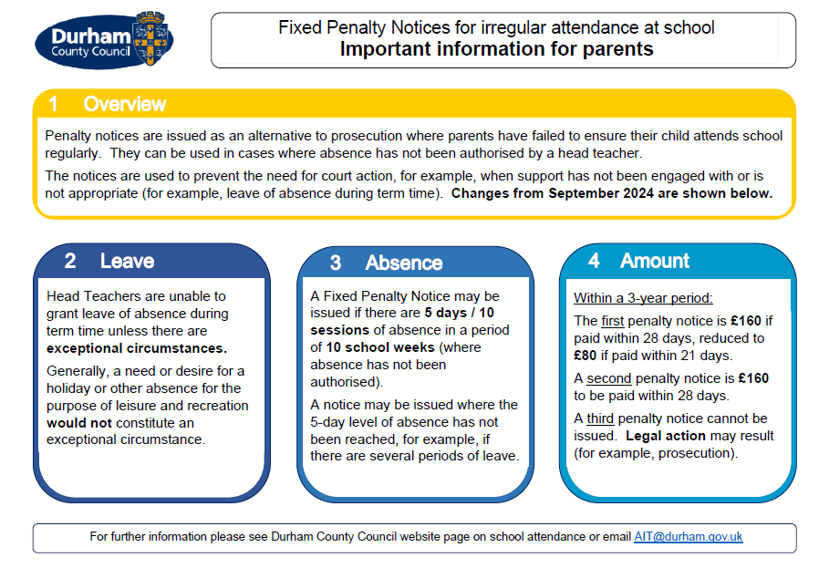

Appendix 8

Key Contacts

Attendance Officer | Julie Bushby | 01325 430250 (Option 1 for attendance)  Julie.Bushby@utcsouthdurham.org
SLT Attendance Champion | Laura McAllister | Laura.McAllister@utcsouthdurham.org
Attendance Governor

