UTC South Durham Learning and Teaching Policy | 

Date of adoption | December 2025
Approved by | Board of Trustees
Signed: (Principal)   | Date:  12 December 2025
Signed: (Chair of Trustees)   | Date:  12 December 2025

Date to be reviewed by | September 2028
Review History | Reviewed – Laura McAllister - Dec 21  Reviewed – Laura McAllister - Sept 25
Responsibility | Vice Principal T&L

- Statement of principles

The purpose of this policy is to enable UTC South Durham to:

- Enable all students to achieve their full potential
- Improve the quality of learning and teaching
- Raise expectations and standards
- Realise our vision and aims – to ensure our students are career and life ready.

At UTC South Durham our curriculum is designed to:

- Support innovative learning and teaching so that exciting and stretching opportunities exist for all our students
- Enable our partners to work with us to ensure that learning is exciting, engaging and related to their industries
- Deliver the main outcome for students, which is to ensure that they have the Core Skills, Academic and Technical Knowledge and Understanding and access to Professional and Career Experiences to enable them to become Career and Life ready.
- Deliver the core skills of Communication, Collaboration, Perseverance, Organisation, Reflection and Respect; central to student development. These are as important as the achievement of qualifications
- Entice and engage students in Project Based Learning (PBL). This will be in the form of inquiry-led projects which deliver Academic and Technical curriculum content alongside opportunities to develop Core Skills and professional and career experiences.
- Allow each year group to work on major work-related projects. These projects will be designed in conjunction with local employers and involve both practical and theoretical elements. Pitches and presentations to employers will be part of the assessment as well as adding the motivation of a competitive element. Projects will promote collaborative and enquiry-led learning and foster self-confidence and independence in students

- UTC South Durham Student Leaver Profile
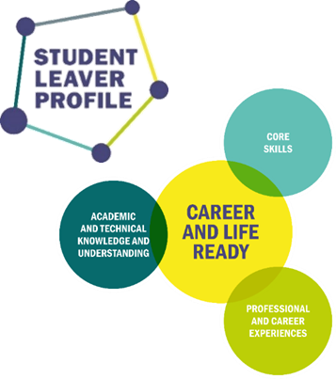
Created in collaboration with our stakeholders, the Student Leaver Profile (SLP) is at the heart of our educational offer and, as such, directly informs our Teaching and Learning Strategy. We believe that the academic and technical outcomes for our students are just as important as the development of their core skills and access to professional and career experiences.

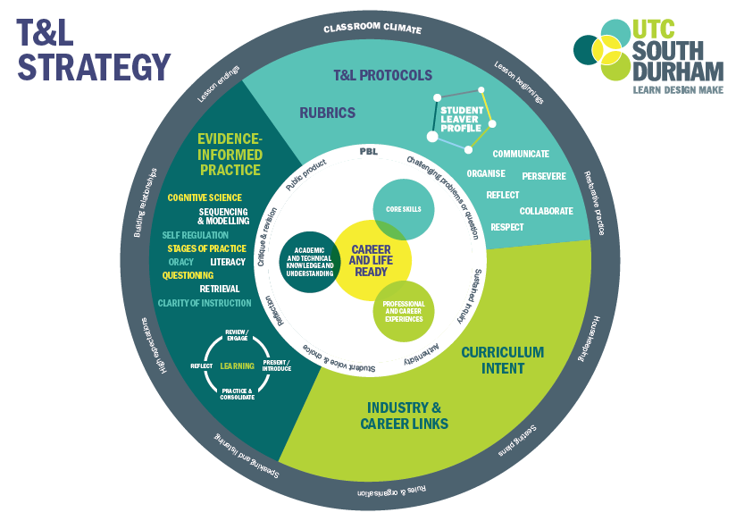
- Effective learning and teaching

At UTC South Durham effective teaching and learning are dependent upon:

- Effective planning using the learning cycle
- Practice informed by the latest evidence-informed pedagogy to ensure that high quality learning can take place. The Education Endowment Foundation (EEF) provides the most up to date evidence base to inform our approaches.
- The use of protocols and rubrics to ensure that students have opportunities to develop their core skills alongside their academic and technical learning
- Links made to careers, industry and real-word application of learning
- Assessment for and of Learning in line with the UTC South Durham Assessment Framework (Appendix 1)
- A calm, professional and business like working atmosphere and classroom climate.

All leading to:

- Career and Life ready students with excellent academic outcomes
- High quality Project Based and Inquiry Led Learning

  - Teaching

For effective learning to occur we expect our teachers to be knowledgeable and enthusiastic about their subject areas and committed to be active learners themselves. We value opportunities for students to speculate, explore and make mistakes. We aim to promote inquiry-led project based learning that mirrors our aims. Therefore, teaching strategies employed should stimulate this style of learning and uphold the ethos and satisfy the principles of this policy. High quality teaching is characterised by:

- Effective planning
- Learning objectives and aims made clear to students
- The teacher’s good subject knowledge and understanding
- Consistently high expectations and challenge for all students
- A range of teaching strategies and styles informed by the latest evidence base planned in to well-structured lessons.
- Practices and approaches which are inclusive for all students, particularly those who are disadvantaged and those with SEND.
- Good working relationships and insistence upon consistently high standards of behaviour
- Frequent praise for good effort and achievement
- Effective use of resources and time with pace maintained throughout the lesson
- Thorough assessment of students’ learning with approaches adapted in response to the data gathered.
- Thorough assessment of students’ work with feedback on how to improve

All of these things should lead to the promotion of good progress and outcomes for students.

3.1a. Safeguarding, Inclusion and Equality

As an organisation, the UTC is committed to ensuring all students have inclusive and safe environments in which to learn, thrive and become career and life ready. This is also in line with our statutory duties under the Equality Act (2010) and the SEND Code of Practice. In planning effective and high quality Teaching and Learning, teachers must ensure they have proper regard for the UTC Safeguarding policy, SEND policy and Equality policy.

Planning and teaching should ensure that learning is accessible to all groups of learners. This begins with Quality-First Teaching (QFT) – following all of the characteristics of high quality teaching - and could also include differentiated resources/delivery, scaffolded learning approaches and adaptive teaching.

  - Support for learning

Students will be supported in their learning by:
- Data driven discussion with their Crew Leader,
- Additional academic mentoring where underachievement is noted,
- Development of study skills, metacognition and self-regulation through lesson delivery and drop down sessions,
- Encouragement through praise and reward, monitored through Class Charts
- Appropriate access to ICT
- Partnership with parents, education and training partners and employers
- Support and enrichment sessions
- Target-setting and monitoring of progress

  - Effective planning

Planning occurs at three levels:

- Long term – through the interlinked UTC Development Plan, Faculty Improvement Plans and Department Improvement Plans. All subjects should outline the overall structure of content over a Key Stage and signpost where industry and technical links, Core Skills and Professional and Career experiences are used to enhance delivery of the curriculum. This should be outlined through curriculum intent documentation.
- Medium term – give greater direction and clarity through schemes of work. Students and parents are given course overviews which highlight key dates for completion of units and assessment dates.
- Short term – through effectively planned lessons and learning sequences using the Learning Cycle

Schemes of work will:

- Sequence and scaffold the learning logically and in order to develop learning over time.
- Sequence learning in line with curriculum intent
- Include a variety of teaching activities and a variety of teaching styles / strategies
- Highlight learning objectives
- Indicate any link with previous work covered and prior learning required of students to access learning
- Indicate common misconceptions so that resources and teaching can address them.
- Summarise the learning activities and the resources needed
- Identify where learning should be assessed in line with the UTC South Durham Assessment Framework (Appendix 1)
- Identify links and collaborative work with other subject areas as well as project work and links with external partners / businesses to allow for work towards PBL as our core pedagogy
- Identify development of core skills / SMSC / British Values
- Outline key dates and deadlines relevant to students’ progression through the course.

At UTC South Durham, we have a wealth of high quality, well qualified and very experienced teachers, and as such we do not expect lessons to be planned to follow a set pro-forma. All teaching staff are expected to meet the Teacher Standards and to consider our guidance documents and Quality Assurance templates when planning and delivering lessons. We believe that this approach will not only deliver a range of outstanding lessons, bespoke to the subject and playing to teacher strengths, but will also reduce teacher workload and promote staff wellbeing. Quality assurance and ECT induction procedures are used to support less experienced teachers and ensure that they plan appropriately.

- Responsibilities

Students must:
- Be punctual to lessons with the correct equipment
- Take ownership for learning and ask relevant questions, strive to progress
- Complete independent learning fully and promptly
- Meet deadlines and hand in books / printed work for timely assessment and feedback
- Take pride in their work and follow the UTC presentation guidelines
- Follow the Student Code of Conduct
- Be reflective and take responsibility for improving their own learning
- Know when to ask for help if needed
- Respect the right of others to learn
- Provide feedback about their learning in a positive and constructive manner

Teachers must:
- Ensure teaching reflects the principles of safeguarding, inclusion and equality
- Share clear learning objectives and success criteria with students and give clear feedback to students on their performance and progress
- Ensure that the lesson content is appropriate to the age and ability of the students, using, where appropriate, differentiated materials and resources
- Ensure that lesson content and learning is accessible for all students including those with SEND or who are disadvantaged
- Maintain a purposeful pace and challenge, and spend as high a proportion as possible of lesson time on learning (as opposed to teaching)
- Demonstrate high expectations of students
- Begin and end lessons on time and in a structured manner, following the protocols outlined in the T&L handbook.
- Value students’ contributions and questions and ensure all students are able to contribute and ask questions where appropriate.
- Make use of praise and reward to underline the value of learning, achievement and progress
- Create a positive and safe learning environment and classroom climate which establishes good working relationships
- Be competent in using a range of datasets for class, sub-group and individuals to inform planning / set challenging targets /provide pertinent feedback / contribute to UTC monitoring systems
- Use Class Charts and CPOMs to accurately record positive and negative behaviours.
- Regularly assess students’ learning in line with the UTC South Durham Assessment Framework (Appendix 1) and adapt teaching and learning strategies in response to this assessment
- Take ownership, with appropriate support, for developing their practices in line with the UTC South Durham Teaching and Learning strategy.

Faculty Directors and Heads of Department are to:
- Monitor the quality of teaching and learning of all teachers in their faculty / department using the agreed QA processes
- Monitor the impact of teaching and learning on student achievement
- Support teachers in their directorate to develop their practices in line with the UTC South Durham Teaching and Learning strategy
- Maintain up to date data tracking spreadsheets which are used regularly to monitor progress, identify underachievement and inform intervention
- Support individual teachers where appropriate
- Ensure that teaching and learning developments are included in faculty / department meeting agendas and faculty/ department CPD activities, and that feedback of department QA is acted upon
- Meet regularly with the VP responsible for teaching and learning to discuss data, QA and any other relevant issues
- Formulate a department improvement plan with the VP with responsibility for teaching and learning annually and where necessary, following a department review
- Be responsible for the co-ordination of long and medium term planning taking into consideration national, local and UTC priorities and developments

Vice Principal for Teaching and Learning is:

- To lead and manage the teaching and learning review process for Faculty / department areas (which involves monitoring the teaching and learning quality of all teachers and providing feedback on learning walks and other QA processes to Heads of Department )
- To formulate, with Heads of Departments and Faculty Directors, teaching and learning action plans following the review process
- To ensure that teaching and learning developments are included in CPD activities and programmes
- To ensure that teaching staff are offered CPD relevant to their individual needs
- Review and propose updates to this policy in the light of on-going developments and the changing needs of the UTC

Trustees are to:

- Seek to ensure that our staff development and our performance management both promote good quality teaching
- Support the use of appropriate teaching strategies by allocating resources effectively
- Ensure that the UTC buildings and premises are in good condition and best used to support learning and teaching
- Monitor the effectiveness of the UTC’s teaching and learning approaches through the UTC’s self-review processes, which include reports from subject leaders, the Principal’s termly report to trustees, and a review of the in-service training sessions attended by staff

Parents / Carers are to:

- Ensure their child attends the UTC regularly and punctually
- Ensure their child attends the UTC with the correct uniform, equipment and PE kit
- Give due importance to revision and consolidation of learning outside of UTC hours and support their child to develop literacy and numeracy skills
- Inform the UTC if there are matters outside the UTC that are likely to affect their child’s performance or behaviour
- Provide support for discipline within the UTC
- Be realistic about their child’s abilities and promote a positive attitude towards the UTC and learning in general
- Fulfil the requirements set out in the home-UTC agreement.

- Support for staff

Staff will be supported in implementing the policy through Professional Development opportunities. These opportunities will include but not be limited to:
- Sharing good practice through learning walks, peer observations, CPD / department time, and whole college collaborative opportunities.
- Identification of high quality training and progression opportunities.
- Bespoke CPD to meet individual needs.
- Regular and meaningful performance review by SLT, FDs and HODs

- Monitoring and Evaluation

It is the responsibility of all teaching staff to ensure this teaching and learning policy is adhered to. This will be supported by a programme of monitoring and evaluation directed by the Vice Principal responsible for teaching and learning, involving all teaching staff in the process.

The T&L Monitoring and Evaluation process is designed to:
- Support on going professional development for teaching staff, giving teachers ownership of this development.
- Identify training needs and areas for professional development as well as any cause for concern*.
- Give leaders a clear picture of the quality of provision (either holistically or a particular aspect of it) across the UTC in order to inform ongoing planning and development and implement any support required.
In addition to this, teaching staff may also choose to use the feedback they receive throughout the process as evidence of progress towards appraisal objectives.
*Leaders will not identify a cause for concern based on only one element of the programme but instead a triangulation of elements* (below) of the programme.

*The programme of monitoring and evaluation could take the form of:
- Learning walks (max 20mins) and/or Lesson observations (20mins+)
- Student work sampling
- Student voice feedback (this will be gathered through learning walks/lesson observations as well as through the student work sampling process) as well as parental and other stakeholder feedback where necessary/appropriate
- Analysis of students’ progress and attainment data (from data collections as well as department data)
- Analysis of Classcharts data – looked at half termly by HoD/F
- Faculty/department QA cycle as well as subject quality assurance e.g. subject reviews

Any of the above elements of monitoring and evaluation may also be used as evidence to contribute towards demonstration of meeting an appraisal objectives at the choice of the appraisee. Teachers will receive personalised feedback and actions from Learning walks, Lesson observations, Student work sampling and Student Voice which will then also be used as a focus for subsequent development and monitoring and evaluation. This data will also be collated and shared with HoD/F and Line Managers and will inform (along with analysis of students’ progress and attainment data and analysis of Classcharts data) part of the discussions and subsequent action planning towards the Department Improvement Plan (DiP*) during the termly QA meetings.

* DiPs will be written collaboratively to involve all members of a teaching team and will be informed by a combination of cross-college and department/faculty priorities. The DiPs will subsequently be used to inform teacher appraisal objectives.

- Other Policies / Documents

This policy should be read in combination with other UTC South Durham policies / documents:
- Safeguarding policy
- SEND policy
- Equality policy
- Assessment Policy
- Attendance Policy
- Behaviour Policy
- Curriculum Policy
- SEND Policy
- Staff Appraisal Policy
- ECT policy

Appendix 1


Assessment Framework

Expectations:

- Written work is marked, marked for spelling punctuation and grammar (SPaG), and assessed at least every 12 lessons.
- Assessments are robust and provide evidence to support fair and accurate predicted grades.
- Students are given regular constructive feedback which facilitates academic, technical, personal and professional improvement, against the six core skills outlined in the Student Leaver Profile (SLP).
- Students are provided with opportunities to respond to that feedback in order to develop or strengthen their learning. Students complete this response in green pen.
- Students are clear about what grade they are working at and where their strengths and weaknesses lie in relation to each area of the SLP. They know what they need to do to improve academically, technically, professionally and personally.
- Students are clear about what their performance in an assessment means in relation to their progress. Students do this by RAG rating their performance – using colour coded red, amber and green against criteria.
- Measures are taken to ensure students can reflect upon their own performance and identify themselves, with appropriate support, what they need to do to improve.
- Students track their own performance and required improvements over time.
- Teachers / Subject areas track student performance in assessments over time.

A student should be able to:
- Show you examples of assessed work.
- Explain their areas of strength and weakness and what they need to do to improve.
- Tell / Show you their target grade.
- Show you examples of where they have developed their core skills.

A classroom teacher should be able to:
- Provide examples of assessed work.
- Provide examples of how SLP is being developed.
- Show and describe records of how students are performing over time in their classes.
- Explain how they are using assessments and grades to inform predictions and planning.
- Have knowledge of who is underachieving and be able to describe actions being taken to address concerns.
- Conduct and respond to assessment for learning within each lesson.

A Head of Faculty / Dept / Subject should be able to:
- Show and describe departmental tracking
- Describe and explain the processes in place to ensure regular and accurate assessment is taking place in their area.
- Describe processes used to moderate predicted grades.
- Be able to provide an overview of performance across the department and actions being taken to address any concerns.

Assessment Framework and SPaG marking guidance

Expectations:

- Where students can write in full sentences, they should do so.
- Students should be expected to proof read their work and make corrections as needed.
- Staff can demonstrate evidence of essential literacy marking where appropriate.

SPaG Marking:

- Ensure student has used capital letters and basic punctuation (full stops, commas, apostrophes, questions marks and exclamation marks) accurately.
- Call attention to spelling mistakes and direct students to copy out the correct spelling three times. Where spelling is a difficulty for the student concentrate only on basic, common words and technical terms – try to avoid any more than 3 corrections at any time.
- Ensure students are using paragraphs as needed.

